**PREDICTION OF TEC VARIATIONS WITH ARTIFICIAL INTELLIGENCE USING SPACE WEATHER DATA AS INPUT**

**Field of invention**

The present invention relates to the field of space weather forecasting and artificial intelligence. Specifically, it focuses on the prediction of Total Electron Content (TEC) variations using advanced machine learning algorithms and space weather data as input. The invention leverages AI techniques to analyze and interpret complex space weather data, providing accurate and timely predictions of TEC variations. These predictions are crucial for improving the reliability and performance of satellite-based communication and navigation systems, which are affected by ionospheric disturbances. The invention addresses the need for enhanced predictive capabilities in space weather research and its applications in various technological domains.

**Motivational Background**

The increasing reliance on satellite-based communication and navigation systems makes it essential to accurately predict ionospheric conditions. Variations in the Total Electron Content (TEC), influenced by space weather, can disrupt these systems and create significant challenges. Traditional methods for predicting TEC variations have had their limitations, leading to the exploration of new approaches. The development of artificial intelligence (AI) offers promising tools to analyze complex space weather data and improve prediction accuracy. Our project, "Prediction of TEC Variations with Artificial Intelligence Using Space Weather Data as Input," aims to enhance the reliability of satellite-based systems. By applying AI to forecast TEC variations, we seek to support the stability and efficiency of critical technologies and advance space weather research.

**Diagram**

ER Diagram

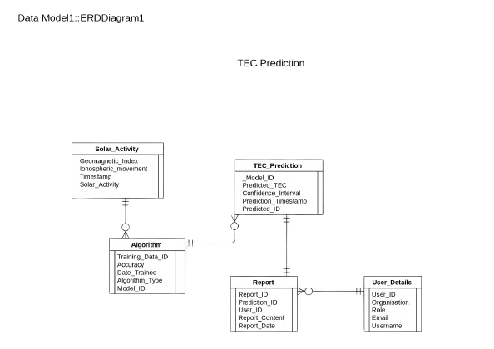

Flowchart

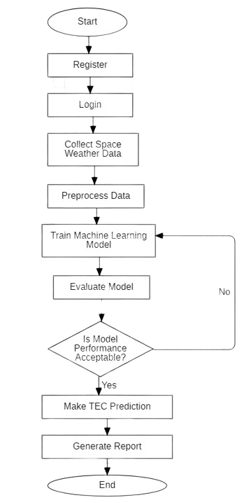

**Claim**

The invention claims a unique and specifically designed system and method for predicting Total Electron Content (TEC) variations in the Earth's ionosphere using artificial intelligence (AI) techniques, tailored for Indian regions. This solution fills a significant gap in the Indian space weather monitoring and forecasting domain, where previous systems lacked such advanced predictive capabilities. The system incorporates data collection modules to gather historical TEC data and real-time space weather information relevant to Indian geographical regions. An AI-driven prediction model, trained and validated using Indian-specific data, enables accurate forecasting of TEC variations. The system's user interface provides TEC predictions, alerts for significant variations, and recommendations customized for optimizing satellite operations and communication protocols in Indian contexts. This innovative solution addresses the unique challenges of space weather forecasting in Indian regions.

**Technology Used**

* Streamlit Community Cloud: A platform for deploying and sharing interactive Python applications, ideal for showcasing machine learning models and data visualizations.
* Python: A versatile programming language widely used in data science and machine learning for its readability and extensive library support.
* Machine Learning and Related Libraries:
  1. Scikit-Learn: A library for building and evaluating machine learning models, offering tools for classification, regression, clustering, and more.
  2. Numpy: A library for numerical computing with support for large arrays and matrices, essential for data manipulation.

3) Pandas: A library for data manipulation and analysis, providing data structures like DataFrames for efficient handling of structured data.

4) TensorFlow: An open-source framework for building and deploying machine learning and deep learning models, developed by Google.

**Abstract**

The project "Prediction of TEC Variations with Artificial Intelligence Using Space Weather Data as Input" aims to enhance the accuracy of Total Electron Content (TEC) forecasts through advanced machine learning techniques. TEC variations, influenced by space weather phenomena, significantly impact satellite-based communication and navigation systems. Traditional prediction methods often fall short due to the complex and dynamic nature of space weather. This project addresses this challenge by leveraging artificial intelligence to analyze and interpret extensive space weather data, providing precise predictions of TEC variations. Utilizing Streamlit Community Cloud for deployment and Python for development, the system integrates key machine learning libraries, including Scikit-Learn, TensorFlow, Numpy, and Pandas, to build and train predictive models. The AI-driven approach enables real-time forecasting and continuous adaptation to new data, improving the reliability of satellite systems and supporting advanced space weather research. By focusing on the specific needs of India and its regions, this project contributes to the advancement of space weather prediction technologies and their application in critical communication and navigation infrastructure.

**End Users**

The end users of the system for predicting TEC variations with artificial intelligence are diverse and include:

* Satellite Operators and Service Providers**:** Organizations managing satellite communication and navigation systems can utilize the predictions to enhance the reliability and accuracy of their services, mitigating the impact of ionospheric disturbances on satellite performance.
* Government Agencies: Agencies responsible for space weather monitoring and management can use the forecasts to develop policies and strategies for protecting critical infrastructure from space weather effects.
* Telecommunications Companies: Companies providing telecommunications services can leverage the TEC predictions to optimize signal transmission and improve service quality, reducing disruptions caused by ionospheric variations.
* Research Institutions: Academic and research institutions studying space weather and its impacts can benefit from the detailed TEC forecasts for their research and development projects.
* Aerospace Industry: Companies involved in aerospace and satellite manufacturing can use the predictions to design systems that are more resilient to ionospheric disturbances, enhancing the performance and reliability of their products.

**Advantages**

* Improved Accuracy: Enhances the precision of TEC predictions, leading to more reliable satellite communication and navigation systems.
* Real-Time Forecasting: Provides real-time predictions, allowing for timely responses to space weather changes.
* Adaptability: Continuously updates models with new data, ensuring predictions remain accurate over time.
* Regional Customization: Tailors predictions to the specific needs of India and its regions, improving local infrastructure resilience.
* Support for Research: Aids in space weather research by providing detailed data and forecasts, contributing to scientific advancements.
* Risk Mitigation: Reduces the risk of disruptions in critical services by offering early warnings and predictive insights.

**Conclusion**

In conclusion, the development of a system for predicting TEC variations using artificial intelligence offers a robust and innovative solution to the challenges posed by ionospheric disturbances on satellite communication and navigation systems. This technology enhances the accuracy and reliability of TEC predictions, benefiting a wide range of end users, including satellite operators, government agencies, and telecommunications companies. The Software Requirements Specification (SRS) outlines the system's functionality, user interface, and performance criteria, ensuring it meets the needs of its users while adhering to high software quality standards. The future potential of this system is significant, with opportunities to integrate with emerging technologies, expand its application across different regions, and contribute to the broader field of space weather research. By leveraging AI for space weather forecasting, the project holds the promise of making satellite-based services more resilient and reliable, ultimately supporting both technological advancements and the protection of critical infrastructure.

**Authors List**

|  |  |  |
| --- | --- | --- |
| **NAME** | **EMAIL** | **E-SIGN** |
| Ananya Srivastava | ananya.2125cs1114@kiet.edu |  |
| Manas Rai | [manas.2125cs1074@kiet.edu](mailto:manas.2125cs1074@kiet.edu) |  |
| Aryan Kaushik | aryan.2125cs1203@kiet.edu |  |